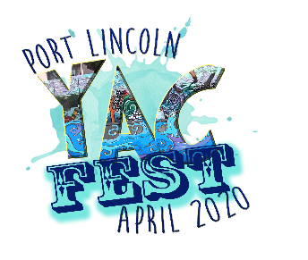
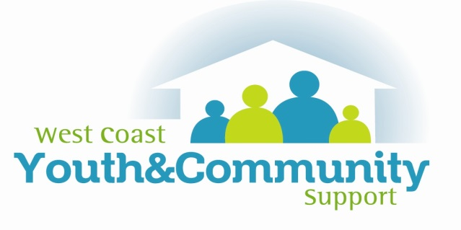
South Australia 5606
T: 08 8683 0072
Facsimile: 08 8683 0072
E: wcycs@wcycs.com.au
www.wcycs.com.au
ABN: 85 014 132 055
1/7 Mortlock Terrace
PO Box 1416
Port Lincoln SA

OUR COMMUNITY YOUTH AWARDS
NOMINATION FORM
Are you or do you know a young person doing amazing thing in our community?

AWARD SELECTION
- Positive Social media inspiration
- Youth Leadership
- Contributions to the community
- Personal Achievement
- Cultural Connections

NOMINEE INFORMATION

Name:
Age:
Email:
Phone:

NOMINATORS INFORMATION

Name:
Phone:
Relationship to Nominee:

Please send nomination before Friday 17th April, 2020, to bek@wcycs.com.au
We aspire to a thriving community where all people are valued

South Australia 5606
T: 08 8683 0072
Facsimile: 08 8683 0072
E: wcycs@wcycs.com.au
www.wcycs.com.au
ABN: 85 014 132 055
1/7 Mortlock Terrace
PO Box 1416
Port Lincoln SA
We aspire to a thriving community where all people are valued

REASON FOR NOMINATION

What great things have you / the young person done in this community?

Why should they/you receive this award?

Supporting material (please attach to the application form)

Please send nomination before Friday 17th April, 2020, to bek@wcycs.com.au

