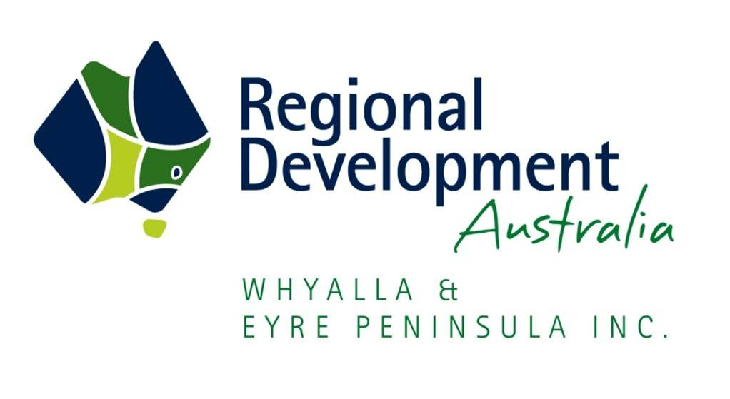

REGISTRATION OF PRELIMINARY INTEREST -
IRON ROAD PROJECT (CAPE HARDY PORT)

Reference number: CPHDYPT112017
Issue Date: 04 May 2017
Project Sponsor RDAWEP
Place for lodgement: 89 Liverpool Street
Port Lincoln SA 5606
reception@rdawep.org.au

REGISTRATION OF PRELIMINARY INTEREST –
IRON ROAD PROJECT (CAPE HARDY PORT)

INVITATION

Iron Road Limited (Iron Road, ASX: IRD) is pleased to advise that two key approvals required for the Central Eyre Iron Project were granted by the South Australian Government on 3rd May 2017. The Central Eyre Iron Project has generated significant momentum towards financing and construction, with the rail and port components declared a Priority Project by Infrastructure Australia in September 2016. Progress has been backed by a strong relationship with strategic partner China Railway Group Limited (CREC). View the full media release here.

Regional Development Australia Whyalla and Eyre Peninsula (RDAWEP), on behalf of Iron Road Limited (Iron Road), are accepting Expressions of Interest from individuals and businesses interested in the Cape Hardy Port development.

The proposed port development is located at Cape Hardy, 7km south of Port Neill on the eastern Eyre Peninsula. All interested parties are invited to register a non-binding preliminary interest in this opportunity in accordance with the following instructions.

Registering a preliminary interest will ensure that you are kept informed in the future about formal opportunities to utilise Cape Hardy and does not bind you, Iron Road or RDAWEP to any firm commitment.

The construction and operation of Cape Hardy as the only Cape Class bulk commodity export facility in South Australia is subject to Iron Road obtaining funding and approvals for its own operations. For further information on the proposed port and the Central Eyre Iron Project, or to keep up to date on progress, please refer to the Iron Road website www.ironroadlimited.com.au.

BACKGROUND

Regional Development Australia is an Australian Government initiative established to encourage partnership between all levels of government and industry to enhance the growth and development of Australia’s regional communities. RDAWEP is the peak body driving the expansion and growth of economic activity across the Eyre Peninsula. RDAWEP is seeking to leverage the proposed Cape Hardy port and associated infrastructure with shared users to ensure maximum regional benefit.

Iron Road, a publicly listed company (ASX:IRD), is proposing to develop an iron ore mine near Warramboo on South Australia’s central Eyre Peninsula. Iron Road estimates that the mine, when operating at full capacity, would produce for export up to 24 million tonnes per annum (Mtpa) of 67% iron concentrate for at least 30 years.

To facilitate the export of this iron concentrate, the company is also proposing to develop the Eyre Infrastructure Project which includes a deep water port at Cape Hardy and a
148km heavy-haul, standard gauge rail connection between the proposed mine and port. At present, only a small network of ageing, narrow gauge rail lines exists on the Eyre Peninsula. The proposed infrastructure has capacity to be utilised by other users such as grain exporters, various other primary producers and other businesses in the region. Iron Road has also indicated that the proposed railway has the potential to connect to the National Rail Network.

The Australian Government considers the proposed infrastructure to be nationally significant and has recognised its importance by granting Iron Road Major Project Facilitation service, the only South Australian project to ever receive that status. In addition, Infrastructure Australia has included the Eyre Infrastructure Project on its Priority Project list, making it one of only 10 projects nationwide and the only “Opportunity for Growth” project. The Central Eyre Iron Project was granted State Government mining lease and development approval on 3rd May 2017.

KEY ATTRIBUTES OF THE PROPOSED CAPE HARDY PORT

- Located on the Spencer Gulf, approximately 7km south of Port Neill and 24km north of Tumby Bay
- Benign sea conditions and sheltered gulf location with shipping expected all year round
- Deep open water berths; no dredging required
- Will be the first and only Cape Class bulk commodity wharf in South Australia
- Major transport route access off the Lincoln Highway; ideal location for an intermodal freight and logistics hub
- Existing partnership with Emerald Grain to develop grain export facility and landside storage
- Facility will be managed by a certified and competent port operator

Property
- Total of 1,100 hectares (ha) of gulf front freehold land owned by lron Road
- Land area reserved for lron Road’s activities - approximately 241ha
- Land area reserved for Emerald Grain’s activities - approximately 20ha
- Balance of land potentially available across site to third parties - approximately 840ha

Proposed Facilities
Multi-access marine facilities:
- Stage 1 - Breakwater and Panamax Bulk Commodity Wharf (14m depth)
- Stage 2 - Bulk and Break back Cargo Facility with Lift-on/Lift-off and Roll-on/Roll-off berths (10m depth), tug harbour and service jetty
- Stage 3 - Deep water (20⁺m depth) Cape Class bulk commodity wharf with 70Mtpa ship loading capacity

Multi-use on-shore facilities:
- Electrical power supply, water, cargo laydown areas, workshop & warehousing, customs and security, Harbour Master and Stevedore Office
- Local area data and communication network (4G expected)

Proposed Infrastructure
On-shore:
- Rail wagon unloading facility, bottom dumping receival (lron Road)
- Bulk materials stacking and reclaiming iron concentrate stockpile (lron Road)
- Product conveying to ship loader (lron Road)
- Bulk grain storage and product conveying to ship loader (Emerald Grain)
- Road and Rail Wagon unloading facility and receival (Emerald Grain)

Utilities:
- Potable water supply, surface water runoff management, plant water reticulation and firefighting services, 33kV Power Supply &240-440V reticulation, sewerage reticulation and waste water treatment plant
- Heavy vehicle and engineering workshop building and amenities
- Vehicle wash-down bays
- Warehouse and hardstand areas
- Camp (up to 650 people capacity) with full catering and recreational facilities (construction stage only)

Marine:
- Causeway with safe Tug Harbour / Work boat & Pilot boat jetty
- Power and water to marine side facilities
- Marine (cargo) offloading facility, heavy duty cranage wharfs and hardstand area, lift-on/lift-off and roll-on/roll-off with 210⁺m berths
- Potential early stage grain wharf, Panamax Class (14⁺m) (Emerald Grain)
- Export jetty & wharf (~ 1.3km long), with heavy duty 2 x Cape Class berth (20⁺m)
- Sealed shore to wharf road pavements and layby areas
- Navigational aids, markers and buoys
- Designated safe anchorage areas

Proposed Timing
- Stages 1, 2 and 3 will be completed consecutively within two years of the commencement of the construction phase of the project
- Current scheduling assumes project construction commences in 2018 and the port facilities will be progressively available from mid-2019
- From mid-2019, the facility is expected to be used to land the equipment and modules required by Iron Road for the mine processing plant
- Under this scenario, first concentrate shipment would occur in mid - to late 2021

Rail Network
At this stage the only rail network will be a heavy duty standard gauge rail line between the proposed mine at Warramboo and the port at Cape Hardy. RDAWEP is interested to hear how a possible expansion of the rail network and connection to the National Rail Network may be of benefit to your business.

REGISTRATION OF PRELIMINARY INTEREST SUBMISSION

All interested parties should register their initial interest by completing and forwarding the attached form to the Contact Officer reception@rdawep.org.au or telephone 8682 6588.

NEXT STEPS

All registrations of preliminary interest will be forwarded to Iron Road.

All parties will be contacted by RDAWEP and/or Iron Road as the project develops to discuss their potential ongoing interest in utilising the port facility and to assess the appropriateness of each business with respect to the current design.

IRON ROAD PROJECT (CAPE HARDY PORT)
REGISTRATION OF PRELIMINARY INTEREST FORM

Information | Response
Name of individual or business:

Contact Name and Title:

Address:

Postal address:

Contact number:

Email:

Website:

Your interest in the project:

